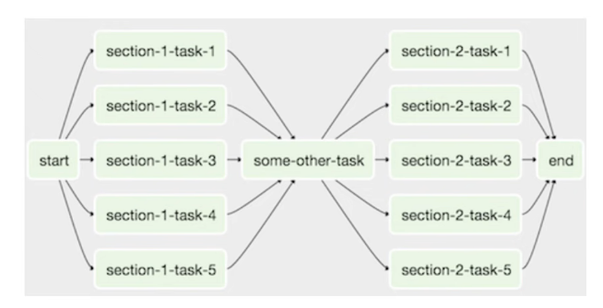

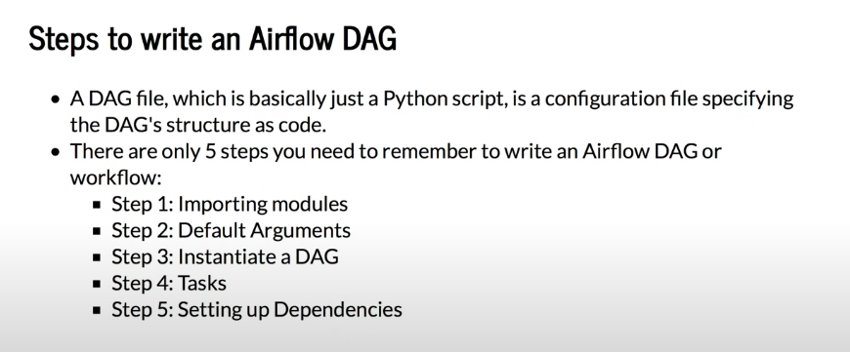

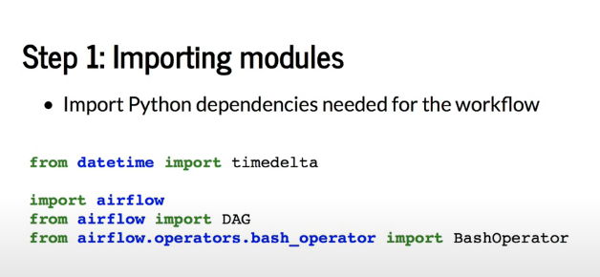

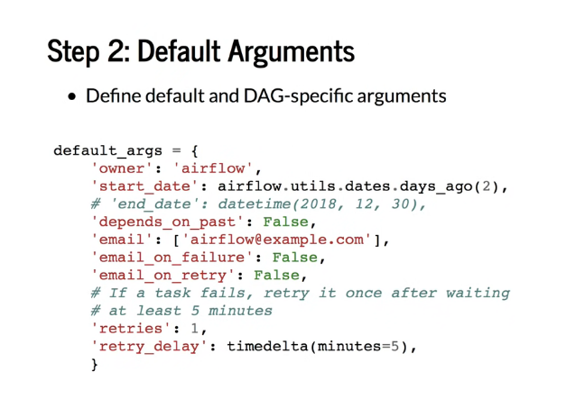

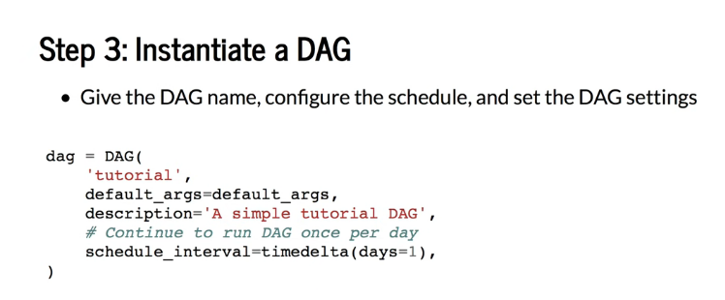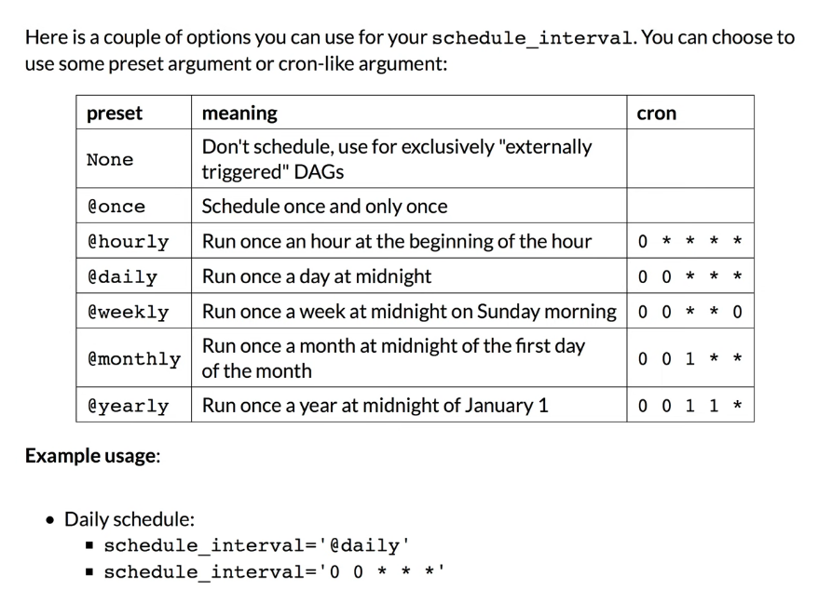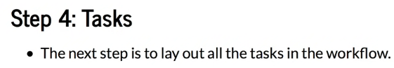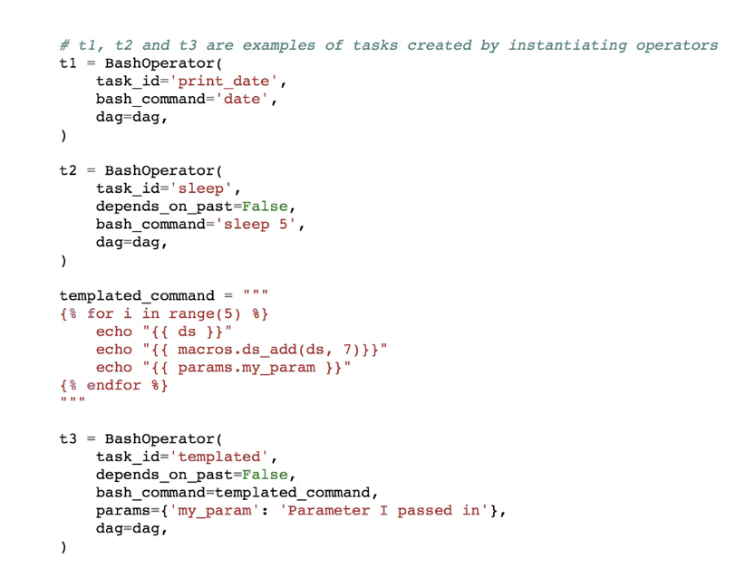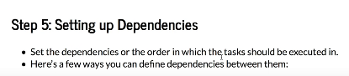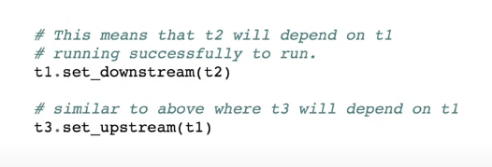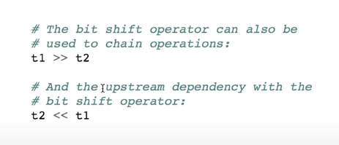

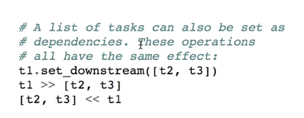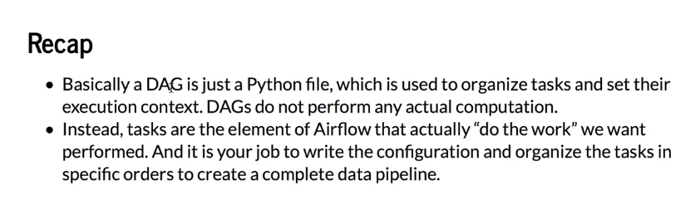

First example code-

# -*- coding: utf-8 -*-

#

# Licensed to the Apache Software Foundation (ASF) under one

# or more contributor license agreements.  See the NOTICE file

# distributed with this work for additional information

# regarding copyright ownership.  The ASF licenses this file

# to you under the Apache License, Version 2.0 (the

# "License"); you may not use this file except in compliance

# with the License.  You may obtain a copy of the License at

#

#   http://www.apache.org/licenses/LICENSE-2.0

#

# Unless required by applicable law or agreed to in writing,

# software distributed under the License is distributed on an

# "AS IS" BASIS, WITHOUT WARRANTIES OR CONDITIONS OF ANY

# KIND, either express or implied.  See the License for the

# specific language governing permissions and limitations

# under the License.

"""

### Tutorial Documentation

Documentation that goes along with the Airflow tutorial located

[here](https://airflow.incubator.apache.org/tutorial.html)

"""

from datetime import timedelta

import airflow

from airflow import DAG

from airflow.operators.bash_operator import BashOperator

# These args will get passed on to each operator

# You can override them on a per-task basis during operator initialization

default_args = {

    'owner': 'airflow',

    'depends_on_past': False,

    'start_date': airflow.utils.dates.days_ago(2),

    'email': ['airflow@example.com'],

    'email_on_failure': False,

    'email_on_retry': False,

    'retries': 1,

    'retry_delay': timedelta(minutes=5),

    # 'queue': 'bash_queue',

    # 'pool': 'backfill',

    # 'priority_weight': 10,

    # 'end_date': datetime(2016, 1, 1),

    # 'wait_for_downstream': False,

    # 'dag': dag,

    # 'adhoc':False,

    # 'sla': timedelta(hours=2),

    # 'execution_timeout': timedelta(seconds=300),

    # 'on_failure_callback': some_function,

    # 'on_success_callback': some_other_function,

    # 'on_retry_callback': another_function,

    # 'trigger_rule': u'all_success'

}

dag = DAG(

    'tutorial',

    default_args=default_args,

    description='A simple tutorial DAG',

    schedule_interval=timedelta(days=1),

)

# t1, t2 and t3 are examples of tasks created by instantiating operators

t1 = BashOperator(

    task_id='print_date',

    bash_command='date',

    dag=dag,

)

t1.doc_md = """\

#### Task Documentation

You can document your task using the attributes `doc_md` (markdown),

`doc` (plain text), `doc_rst`, `doc_json`, `doc_yaml` which gets

rendered in the UI's Task Instance Details page.

![img](http://montcs.bloomu.edu/~bobmon/Semesters/2012-01/491/import%20soul.png)

"""

dag.doc_md = __doc__

t2 = BashOperator(

    task_id='sleep',

    depends_on_past=False,

    bash_command='sleep 5',

    dag=dag,

)

templated_command = """

{% for i in range(5) %}

    echo "{{ ds }}"

    echo "{{ macros.ds_add(ds, 7)}}"

    echo "{{ params.my_param }}"

{% endfor %}

"""

t3 = BashOperator(

    task_id='templated',

    depends_on_past=False,

    bash_command=templated_command,

    params={'my_param': 'Parameter I passed in'},

    dag=dag,

)

t1 >> [t2, t3]